**Lab 5: Using WebHDFS**

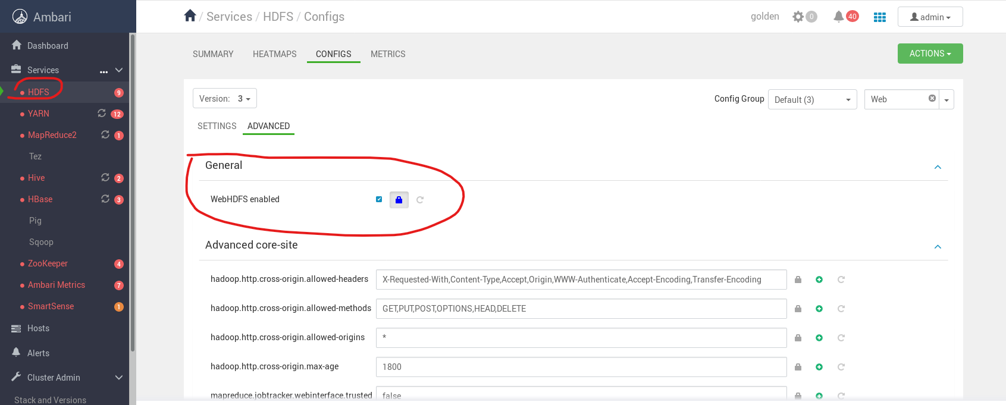

[root@golden-node1 ~]# curl -i "http://golden-node1:50070/webhdfs/v1/user/root?op=LISTSTATUS"

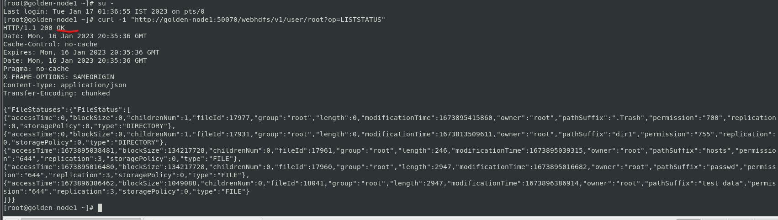

[root@golden-node1 ~]# curl -i -X PUT "http://<NameNode Host>:50070/webhdfs/v1/user/root/history?op=MKDIRS&user.name=root"